 BODYWORKS AQUATHLON: race day information 31st March @ Bedes School, Hailsham. BN27 3QH

Event timetable: Race venue opens at 8:15am.
8.30 am: Registration opens for all in the pavilion
9:15 am: Transition opens poolside for novice, tri starts + Tri star 1
9.50am: All Tri start, all Novice and Tri-Star 1 girls to be at poolside.
10.00am race start for Tri-Starts wave 1 50m
10.05am: race start for Novice 1 wave 2 50m
10.10am: Tristar 1 girls start wave 3 100m
10.10 am Tristar 1 boys onto pool side
10.20am: Tristar 1 boys start wave 4 100m
10.25am: Tristar 2 girls set up transition at poolside (enter pool through external pool door at front of building)
10:30am Tristar 2 boys set up transition at poolside
10.40am: Tristar 2 girls start wave 1 wave 5 200m
10.50am: Tristar 2 girls start wave 2 wave 6 200m
11.00am: Tristar 2 boys start wave 1 wave 7 200m
11.10am Tristar 3 set up transition at poolside enter pool through external pool door at front of building)
11.20am: Tristar 3 girls start wave 1 wave 8 400m
11.30 am Tristar 3 girls start wave 2 wave 9 400m
11:40am: Tristar 3 boys start wave 1 wave 10 400m
11:50 Tristar 3 boys start wave 2 wave 11 400m
12.00 Youth + junior set up transition at poolside enter pool through external pool door at front of building)
12.10 All youth & Junior mixed wave start wave 12 400m
12.20 Adult novice club challenge transition set up at poolside.
12.30: Adults novice start wave 13 200m

REGISTRATION:
This will take place in the Pavilion, follow signs from the car park.
If you are a member of British Triathlon please bring your membership card to registration.
You will receive:
- A race number to be pinned to the front of your running top, or attached securely to a number belt.
- A coloured wrist band, identifying your age group and you as a competitor.
- Triathlon England race day license if you do not have an annual membership.
- Chip to be attached to the left ankle.
- A numbered bag for your hat and goggles to be placed in after your swim in transition.

TRANSITION: This will be located on poolside. Once registered put on your coloured wrist band. each age group will have time to set up their transition before the swim starts. Please only have a small towel, trainers, a t shirt with number attached or a number belt, and your numbered bag in transition. No parents will be allowed into transition. Helpers will be there if needed.

NOVICE RACE: 50m swim up & down your own side of the lane, no diving but tumble turns are allowed.
RUN COURSE: 600m
Novice run route: Run from transition, follow route around field to bottom field. Turn right and run a ½ lap across the field up to finish.

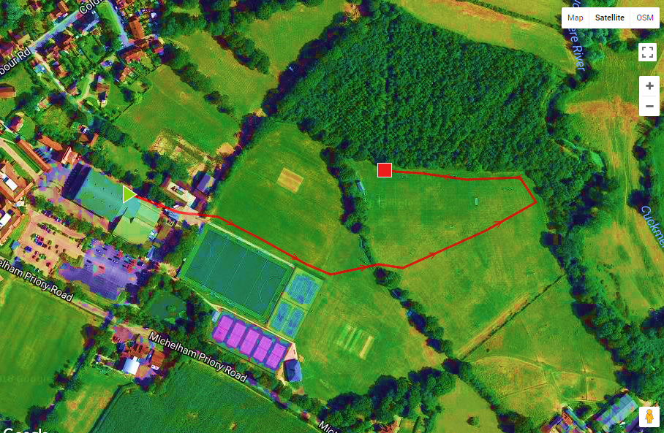

TRISTART RACE:
Swim: 50m up & down your own side of the lane, no diving, tumble turns are allowed.
Run: 600m
Tri start run route: Run from transition, follow route around pitch to bottom field. Run a ½ lap across the field turn left and up to finish.

TRISTAR 1: swim 100m: up & down your own side of the lane, no diving, tumble turns are allowed.
Run Course: 1200m
Run route: run from transition and follow marked route to the bottom field. Follow course anti clockwise around the field for 1 lap followed by a ¾ lap to finish.

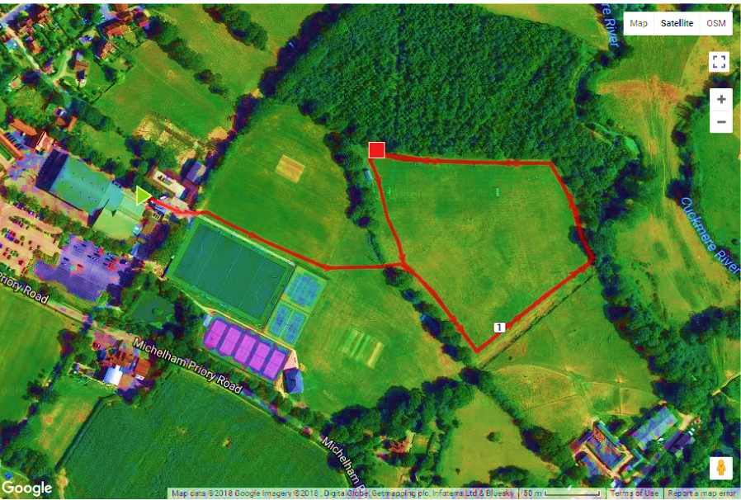

TRISTAR 2 RACE:
Swim: 200m up & down your own side of the pool, no diving but tumble turns are allowed.
Tristar 2 Run route 1800m: run from transition follow marked route to the bottom field. Follow course anti clockwise around the field for 2 laps, then a ¾ lap to the finish.
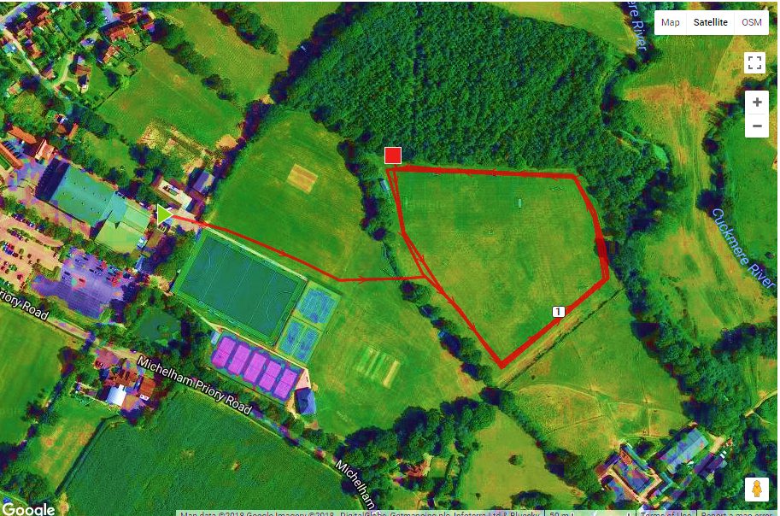

TRISTAR 3
Swim 400m up & down your own side of the lane, no diving but tumble turns are allowed.
Run route 2.4km: run from transition follow marked route to bottom field, turn right, Follow course anti clockwise around the field for 3 laps, then a ¾ lap into the finish

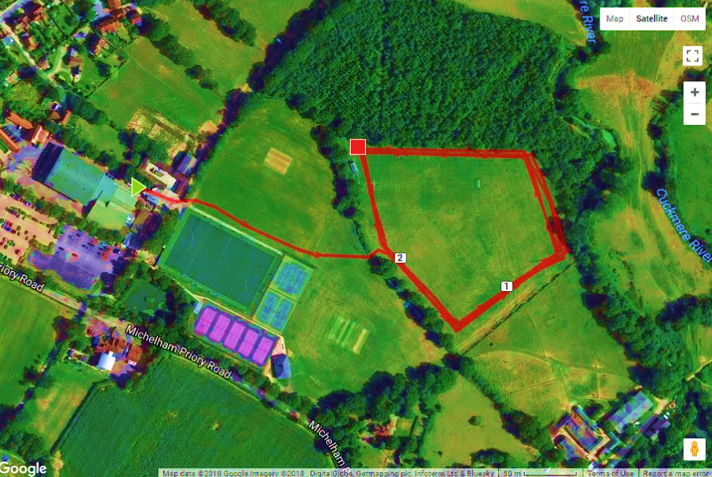

YOUTH: SWIM 400M up & down your own side of the lane, no diving but tumble turns are allowed.
RUN 3KM: exit building, run on path follow route around pitch to bottom field. Run anti clockwise following marked course, 4 laps and a ¾ lap in to finish.

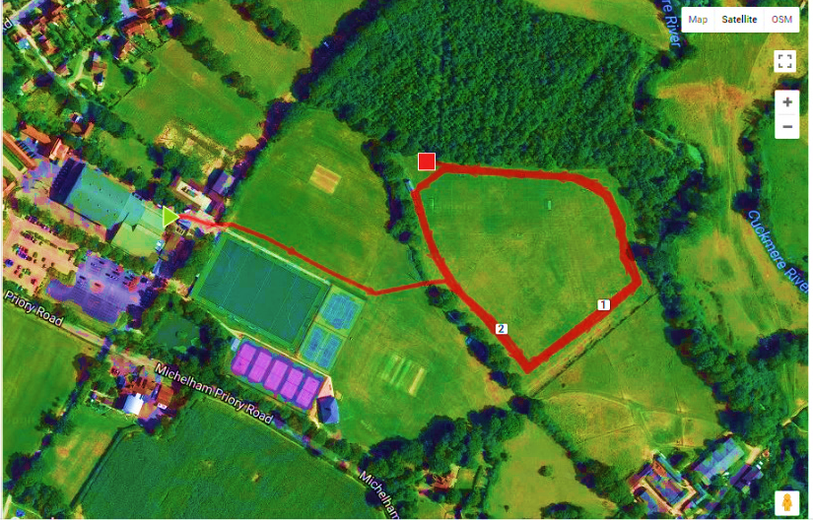

Adult Novice Club Challenge: for Newbies!!
Swim 200m up & down your own side of the lane, no diving, tumble turning is allowed.
Run route 3km: run from transition follow marked route to bottom field, turn right, Follow course anti clockwise round the field for 4 laps, and 3/4 lap to the finish.

COURSE WARM UP:
All athletes will be able to walk and look at the run course until 9:45am. After this the bottom field part of the course will be closed except for those competing. Please respect this to give each athlete a chance to compete without people on their course. You will be able to view it but please warm up away from the course.
RACE BRIEFING:
A race briefing will be done before each race starts on poolside. If you have any questions prior to this please speak with a Marshall (yellow bib), except for the timekeepers.
RACE RULES:
- Each athlete will be assigned a side of the lane to swim in. You stay on this side throughout your swim.
- Athletes will start at the deep end in the water.
- The start will be: On your marks, followed by a whistle signalling the start. Any athlete going before the whistle will receive a 10 sec penalty.
- When you have swam the required number of lengths you climb out and walk to your transition where your shoes will be laid out. Take care of the slippy pool side when wet. NO RUNNING.
- At your transition area you put on your number, either with a number belt or t shirt, everyone must have a top of some description on. (Girls a swim suit is fine, tri suit is fine for both), shoes must be fastened, put your goggles and hat into your numbered bag and leave transition walking through internal pool exit, a left and right turn, follow short corridor to rear external exit, TAKE CARE on exiting, Once you are outside on the path you may start to run.
- Follow the run course which will be signed and marshalled throughout.
- Once you have completed the correct number of run laps run straight into the finish area.
- Make sure your race number is visible on your front throughout the race.
- Unsporting conduct such as but not limited to tripping another competitor, pushing, or deliberately blocking will result in a time penalty or disqualification.
Cutting the run course or incomplete swim lengths will result in disqualification.
Spectators: There is a glass panelled side to the pool which is great to watch from. No parents or spectators will be allowed on pool side due to space availability. Please respect the run route is for the athletes and stay off the course. There will be plenty of areas for watching and supporting the run and an area at the finish to reunite with your child. Please do not run with your child.
Photos:
If you are taking photos during the event, please sign the form at registration and collect a sticker.

Toilets and changing facilities are available at the sports centre.
Drinks and snacks will be available in the Cricket Pavilion during and after the event.
Please note, heat times are given as a guide and there could be slight changes on the day due to over running of a heat.

